**Part 1: Research Notes**

**Ord River Floodplain**

1. **Wetland description (Define what constitutes a wetland and describe the different types of wetlands and what makes them important). (2 marks)**

**Wetlands are known as areas that are permanently seasonally or intermittently waterlogged nor inundated with water. The water can either be salty or fresh. Types of wetlands include:**

* Lakes
* Sumplands
* Damplands
* Playas
* Palusplains
* Barlkarras
* Paulsopes
* Palusmontes

**0 marks-exactly word for word as Jaxson B**

1. **Describe what the Ramsar Convention is and clarify why it is important. (2 marks)**

The Ramsar convention was put together to try and decrease where possible reverse the loss of wetlands and to try and conserve the wetlands that are still living, by using management plans.

**0 marks-exactly word for word as Jaxson B**

1. **Identify which Ramsar Criteria your WA wetland qualifies for. 0 (1 mark)**

**Clearly explain using multiple points how your WA wetlands meets this Ramsar Criteria. (3 marks)**

Criterion 1: This cite represents the best wetland that is associated with the flood pain of a tropical river system in the Kimberley, (Western Australia)

Criterion 2: The ord river protects a number of threatened species

Criterion 3: The ord river contains a extensive and diverse mangrove community with 14 out of 18 species

Criterion 4: The ord river supports species and communities during critical life stages

Criterion 5: Evidence it supports 20 000 water birds

Criterion 6: It supports 1% of the population of plumed whistling duck

Criterion 8: The ord river is an important nursery for at least 50 species of fish

**0 marks-exactly word for word as Jaxson B**

* 1. **Provide a map of your WA wetland site (include geographical coordinates and location of nearest town or major town/city). Ensure that you clearly delineate the various types of wetlands within your site.** **1 mark**

(4 marks)

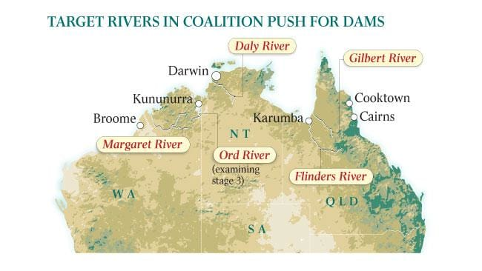

1. **Analyse and describe the key features of your WA wetland site, include the following: biogeography, physical conditions (including climate data), hydrological values, wetland type.** The river spreads across 141 453 hectares and over 200 bird species have been discovered since the start of the convention. It has Seasonal/intermittent freshwater marshes/pools on inorganic soils; includes sloughs, potholes, seasonally flooded meadows, sedge marshes.

**2 marks**

**Where is the hydrological values, average temperature, average annual rainfall?**

1. Use the Fishbone Template to classify noteworthy biotic factors (flora and fauna) that inhabit your WA wetland. For each, describe what makes each one noteworthy.  **(6 marks)**

| Fauna | Fauna | Fauna | Flora | Flora | Flora |
| --- | --- | --- | --- | --- | --- |
| Salt Water crocodile | Black Flying-fox | Agile wallaby | Barringtonia acutangula | Pandanus aquaticus | Acacia neurocarpa |
| The salt water croc is a crocodilian native to saltwater habitats and brackish wetlands from India's east coast across Southeast Asia and the Sundaic region to northern Australia | Black Flying-foxes are the largest species of flying-fox in Australia and they can fly up to speeds of 35 - 40 kilometres per hour | They are one of the most colourful members of the kangaroo family and the largest of the rock wallabies | is a big tree that grows up to 50 feet (15 m) high. Its leaves are thick, smooth and oval in shape | Pandanus is a genus of monocots with some 750 accepted species. They are palm-like, dioecious trees and shrubs native to the Old World | This species is accepted, and its native range is Western Australia to Northern Territory |

1. **Describe if the site has any social and/ or cultural values and detail what makes them important**. The site contains Indigenous burial sites, artefact scatters, quarries, paintings and ceremonial sites, these are important to the people because there previous family members are settled in the soils. ( 4 marks)

**Why else? Explain further. 2 marks**

1. Analyse how current land and water use activities within your site and the surrounding catchment are affecting the ecological character of your WA wetland. **0 marks** (6 marks)
2. Bibliography (Referencing) (3 marks)

**No intext references and not APA style -2 marks**

<http://powo.science.kew.org/taxon/urn:lsid:ipni.org:names:470984-1>

<http://tropical.theferns.info/viewtropical.php?id=Pandanus+aquaticus>

<https://www.environment.gov.au/cgi-bin/wetlands/ramsardetails.pl?refcode=31>

**13/39 + 9/21 = 22/60 =36.7%**